**Kubernetes**

**Kubernetes is developed by google and kubernetes is written by golang.**

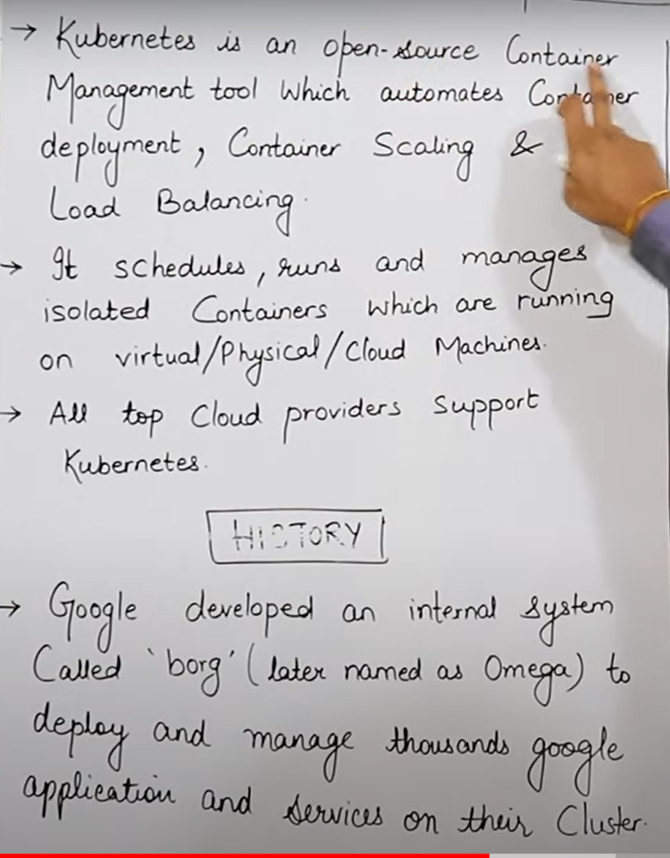

* **Very imp topic**

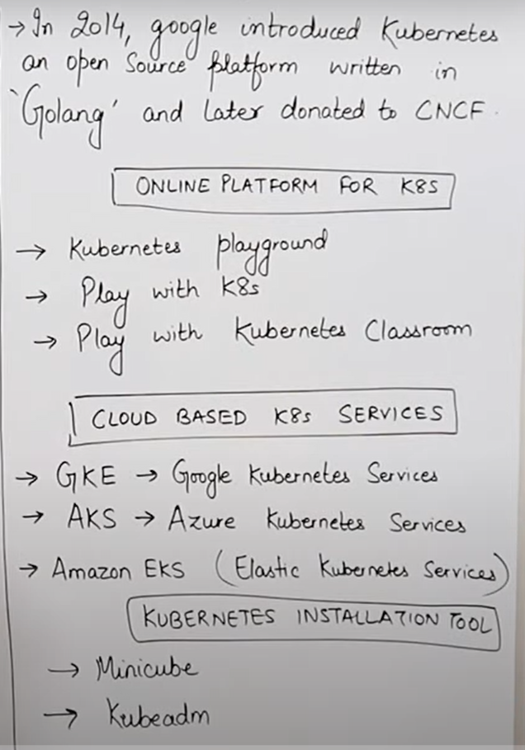

* Cluster is a group of containers.
* If we want to learn kubernetes we have a many online platform to learn :-
* Kubernetes playground
* Play with kubernetes, play with k8s
* Play with kubernetes classroom
* Containers bina kubernetes kein apas mein communicate nahi kar sakte dusare container sein.
* Containers mein bina kubernetes kein hum autoscaling aur load-balancing nahi kar sakte.
* Hum containers ko manage karne kein liye docker swarm ka use kar sakte hai but vo achaa nahi mana jata comparatively kubernetes kein , kubernetes ki market 57% hai aur docker swarm ki kewal 12% hai.,isliye container ko achee sein manage karne vala tool kaha jata hai kubernetes.

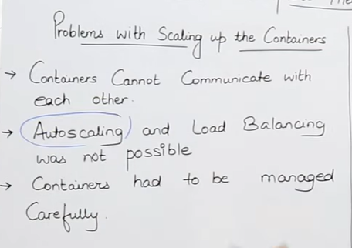

**Features of kubernetes:-**

* Orchestration means hum multiple running containers ko eak sath jod sakte hai chahe vo hybrid cloud mein container bana ho chahe vo virtual cloud mein bana ho aur chahe vo on premises mein container bana ho hum sab container ko eak sath joad sakte hai aur multiple container ko eak sath jodane ko hi hum cluster bhi kehate hai.
* Kubernetes mostly har eak tareeke kein container ko support karta 1-2 hi aise type kein container honge jisko vo support nahi karta.
* Hum autoscaling kar sakte hai container ko vo bhi vertically or horizontally dono tareeke sein.
* **Vertically** scalling ka matlab hai ki for example mere pass koi container bana huva hai jiski ram 2 gb aur mein chahata hu ki us container ki ram 2 gb sein badh kar 4 gb h jaye toh vo bhi ho jayega automatically.

Vertically scallng mein bhi hum eak limit tak apani ram badha sakte hai, matlab jitana mere resource kein pass ram hogi kewal utani hi, matlab agar mene ec2 machine banayi hai usme eak instance mein 264 gb ram sein jada hum use nahi kar sakte but agar humein 264 gb ram sein jada ki jarurat toh humein problem hogi vertically scalling mein, isliye hum jadatar horizontal scaling use karte hai usase fayada ye hota hai ki kubernetes jarurat padne par new instance bhi create kar deta hai.

* **Horizontal** scaling ka matlab hai ki jaise mere pass koi container bana hai uski ram 2 gb hai aur mein chahata hu ki 2 gb ka eak aur container ban jaye matlab 2-2 gb ka do container ban jayega toh vo bhi hum kar sate hai kubernetes mein vo bhi automatically.
* Jada tar hum horizontal scaling ka hi use karte hai vo best hota hai.
* **LOAD BALANCING:-**
* Agar mere pass 2 container bane pade hai aur mein chahata hu jo request user kein taraf sein aarahi usko barabaar sein dono container mein distribute kar dein vo bhi kaam kubernetes karta hai.
* **Fault tolerance :-** Kubernetes hurdum check karta rehata hai ki agar koi server ya pod fail ho raha baar baar toh vo naya server or pod khud sein create kar deta hai , pod kya hota hai hum aage janenge
* **Rollback (going back to previous version):-**
* agar mene koi new version install kiya aur mein chahata hu ki meira purana version hi achaa thaa toh hum vo bhi kar sakte hai kubernetes mein
* **Health monitoring of container:-**
* Agar mera koi bhi container fail ho jata hai toh kubernetes us container ko apane sein bana deta hai .
* Kubernetes meie agar koi script likhani hoti hai toh hum script ko yml file or json file mein likhate hai
* **Batch execution:-**
* Agar mere pass koi code hai aur mein chahata usko step by step vo code chale matlab execute ho toh vo bhi hum kar sakte hai kubernetes mein.

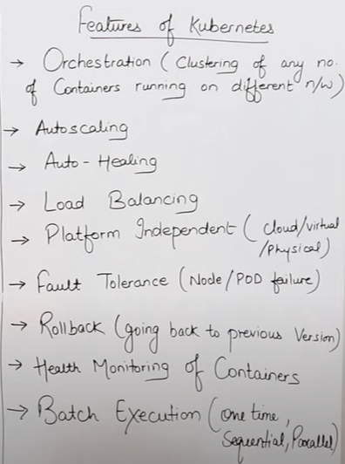

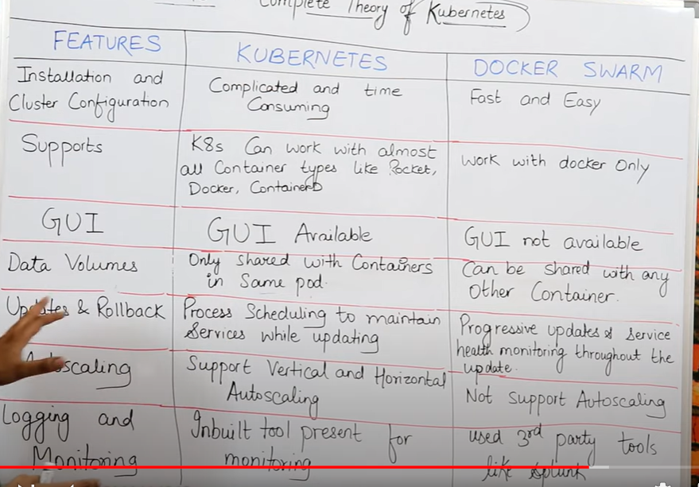

**Cluster**

* Cluster is a group of containers.
* Cluster 2 cheejo sein mil kein banata hai master node or worker node. Master noder instruction deta hai worker node ko phir worker node work complete karne kein baad master node ko inform karta hai.
* **Master node** humara main hoga jaha par humara kubernetes ka server install hoga humare api ka server hoga aur vo humare worker node ko control mein rakhega .master bhi eak tareeke ka server hi hai aur node bhi eak tareeke ka server hi hai
* **Worker node** mein bhi humara server install rehata hai,

**There are mainly three types of cluster:-**

* **1 master -> 1 node**
* **1 master -> multiple node**
* **Multiple master -> multiple node**

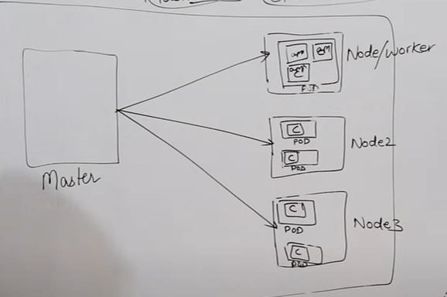

* Hum node kein andar create karte hai kubernetes ki basic unit jisko hum kehate hai **pod , hum 1 node kein andar multiple pod bana sakte hai .**
* Pod kein andar hum containers ko rakhate hai jaruri nahi ki pod mein hum kewal docker kein container rakhe hum pod kein andar kisi bhi tareeke kein containers ko rakh sakte hai
* Kubernetes kabhi bhi container sein baat nahi karta aur nahi containers par kaam karta hai vo hurdum pod sein baat karta hai , aur pod par hi kaam karta hai .
* Generally bola jaye agar toh eak pod kein andar hum eak container ko rakhate hai but hum multiple container bhi rakh sakte hai eak pod mein
* Eak pod kein andar hum multiple nodes rakh sakte hai aur un multiple nodes kein andar hum multiple pod bana sakte hai aur hum un multiple pod kein andar hum multiple container bana sakte hai

